Embedding Your Calendar on Your Google Site
Simply open the page you want to add your calendar on, click Edit. Then go to Insert and select Calendar. Pick the calendar you want to embed and say Select. Then save your page and your calendar will appear. 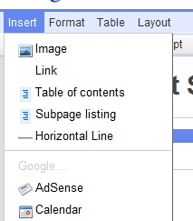 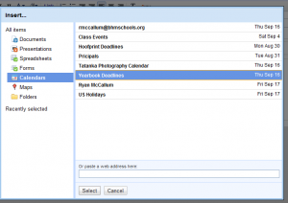

To display multiple calendars in a single embedded calendar, after selecting your first calendar, select Display Another Calendar.

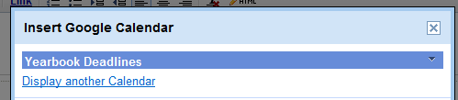

Save your calendar, save your page, and it should be working.

