How to Create a New Google Calendar

You will first want to log into your Google account. When you have logged in you then be on your Google Drive homepage.

Go to the top of you screen and select ‘Calendar’. This will open up your calendar on a new tab.

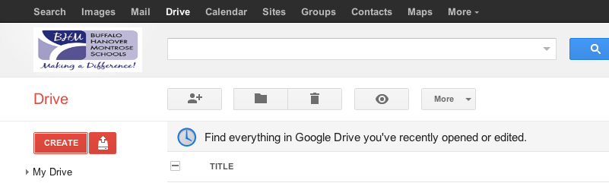

On the left side of the screen you will then want to select the red ‘Create’ button.
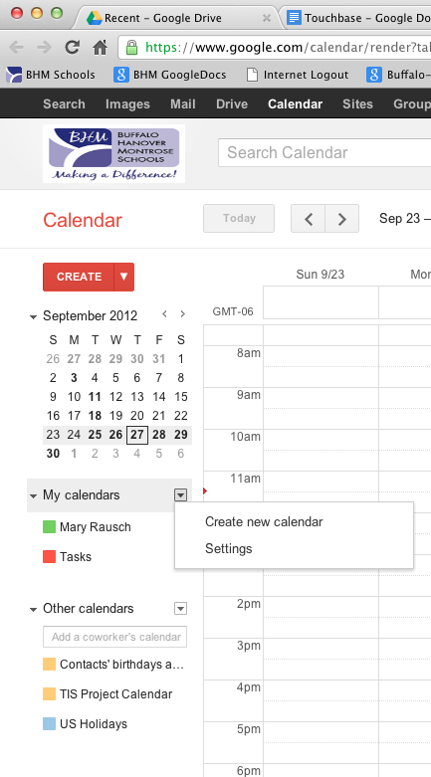

You will now be a new screen. This is where you are going to enter all of the details on your new calendar

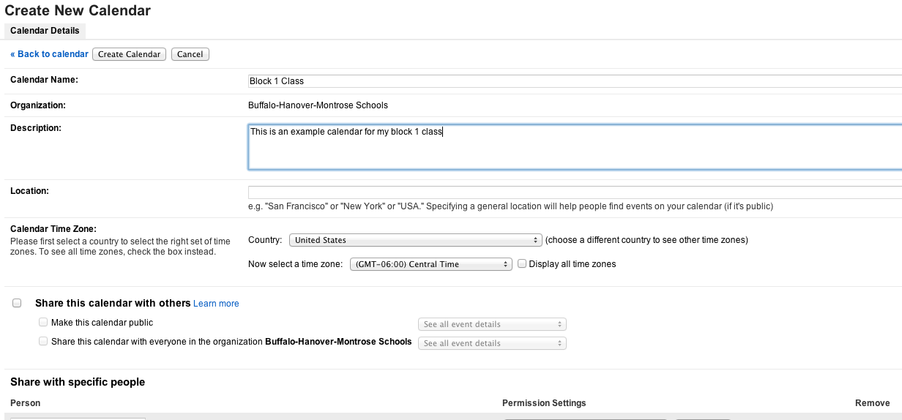

Make sure to add the ‘Calendar Name’ and ‘Description’.

You will then have 2 more choices to make. You can ‘Share your calendar with others’ by making the calendar public or sharing the calendar with everyone in BHM Schools.

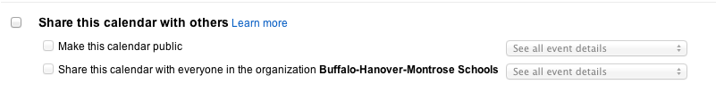

The Second Choice you can make is to ‘Share with specific people’. This is great if you want people in your team to see, or even have it open for you principal to come in and look at.

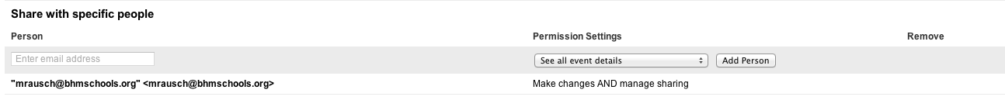

When you add their email addresses you can then change their ‘Permission Settings’. There you will be able to decide what you want that person to be able to do.
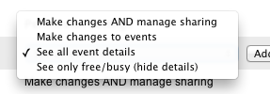

At the bottom of the screen you will now have the option to select ‘Create Calendar’.

You will now be directed to back to your Calendar Main Page.

On the left you will now see your new calendar added under ‘My Calendars’

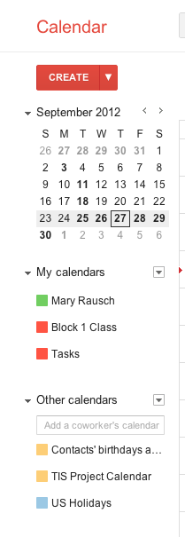

If you need to go back in to edit this calendar select the dropdown next to the calendar name.
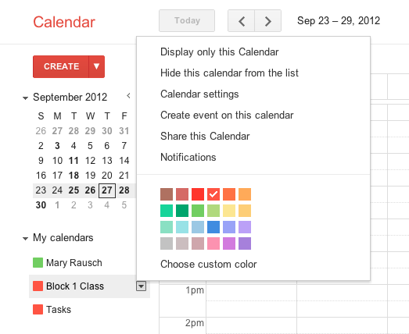

You will now have a list of options to choose from in order to edit your calendar.

Additional Resources
Tech Chicks Website
https://sites.google.com/a/bhmschools.org/the-tech-chicks/home

Google’s Training Center
http://edutraining.googleapps.com/Training-Home/module-3-calendar

