Creating a New Google Group

Once you are logged into Drive. Select Groups at the top of your screen. Then click on New group.
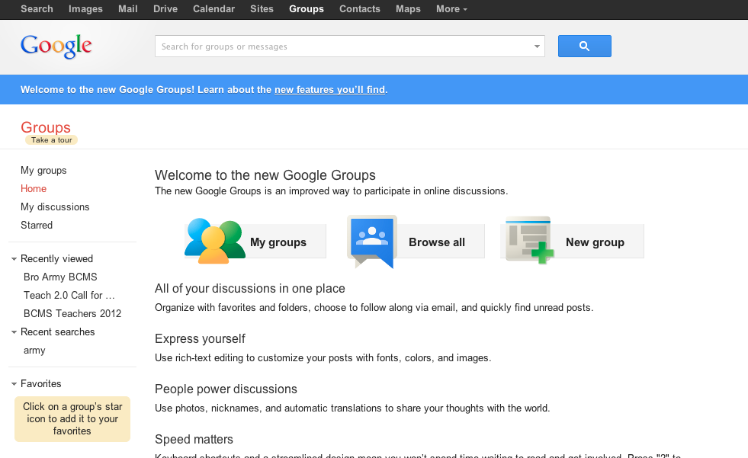
You will now be brought to a new screen. Enter the Group name.

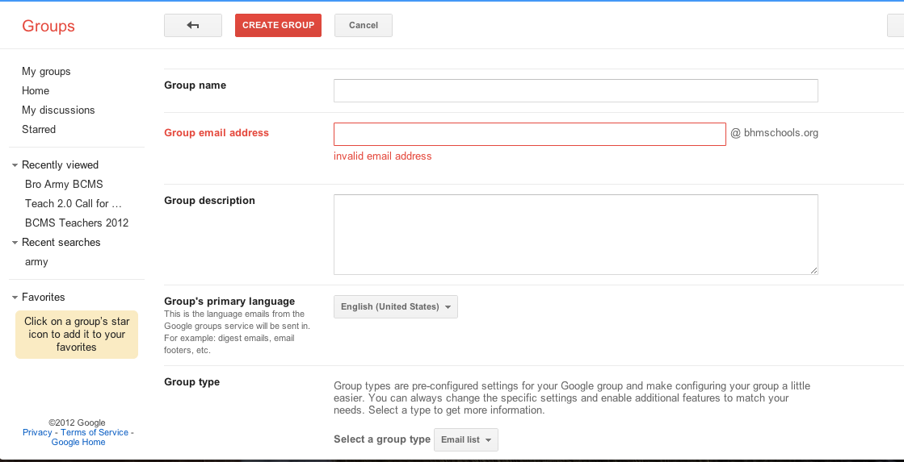
As you can see on the below picture, when you are typing in the Group Name the Group email address will automatically fill in. When you are naming your group always title it School Initials-Last Name-Class-Title-School Year.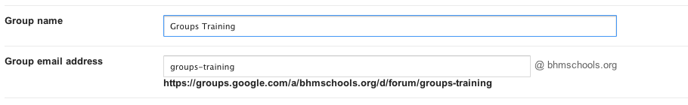Continue down the screen changing any information you feel would suit your Group the best.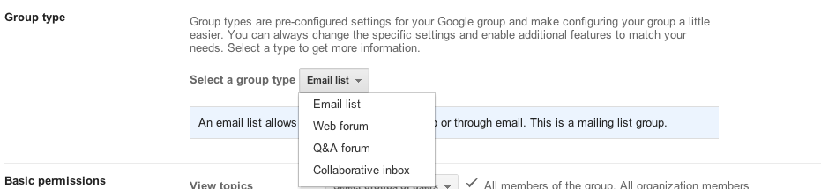

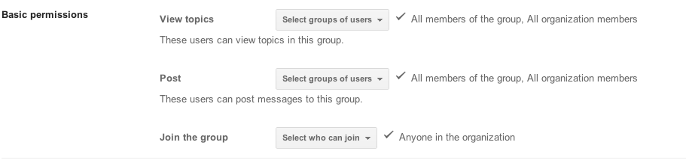
At the top of your screen select the red Create Group button.

You will now be given options to Invite people, change settings, or add a new topic.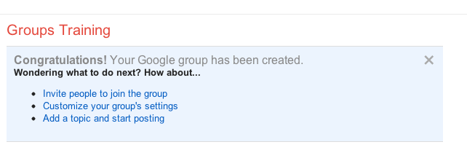When you select Invite people to join the group you will be brought to a new screen and will be able to start entering their email addresses to add them into your Group.
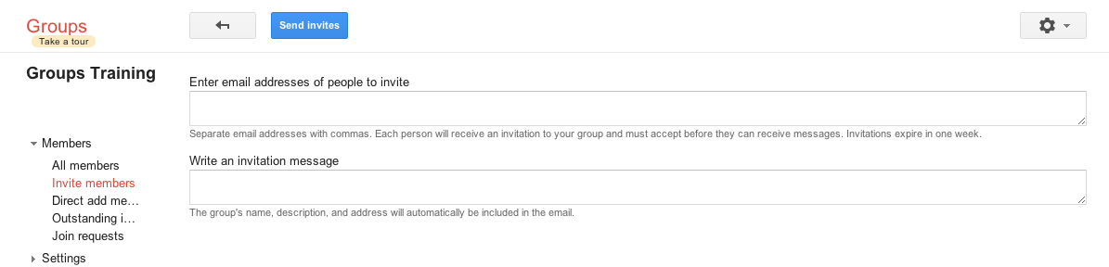
If you selected Customize your group’s settings you will be brought to this page and can use the sidebar to navigate between settings options.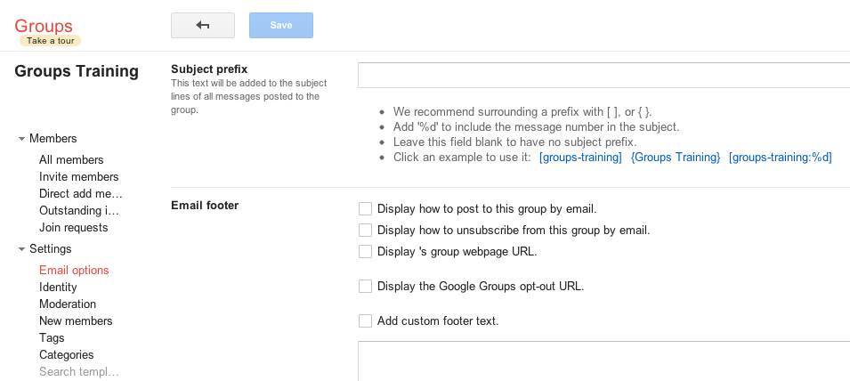
To Add a topic select the red Add Topic button at the top of your screen.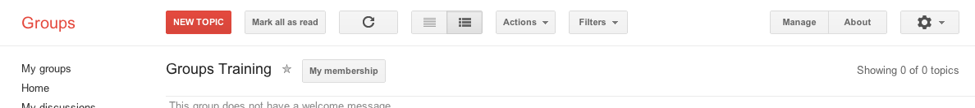
You will now enter the information into your post.
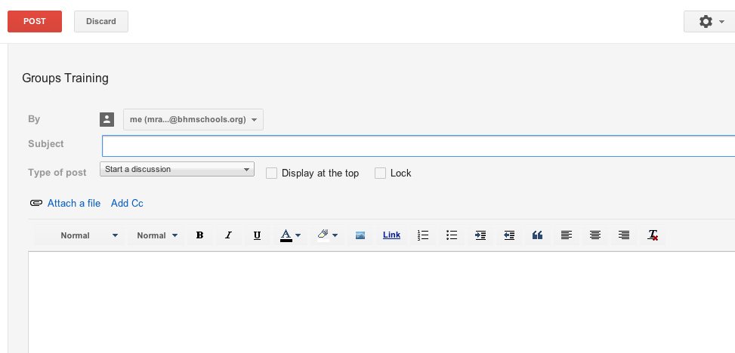
When you are selecting the Type of post you will have these options to choose from.
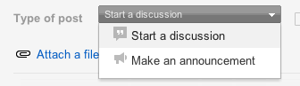
When you are finished select the red Post button at the top of your screen.

