How to Create a New Event in Google Calendar

You will first want to log into your Google account. When you have logged in you then be on your Google Drive homepage.

Go to the top of you screen and select ‘Calendar’. This will open up your calendar on a new tab.
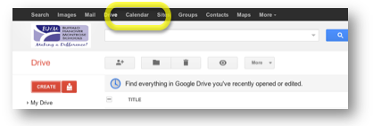

On the left hand side you will want to select the dropdown arrow next to the calendar you would like to add an event to.
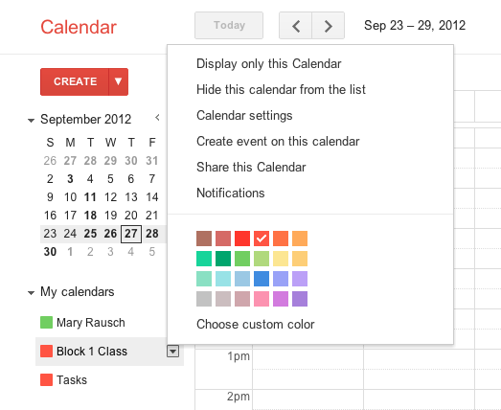

When the new options pop up you will want to select Create event on this calendar.
You will now be on a new window.
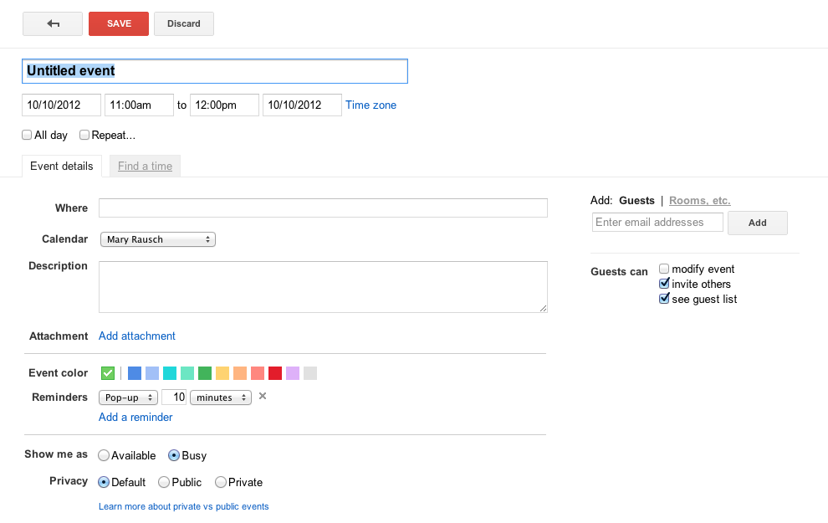

You will want to name your event

When you want to select the date you are creating the event for select the date and a calendar will appear. You can then adjust the time. You will also have the option to have an All day event or have your event Repeat by simply selecting the box underneath the date.
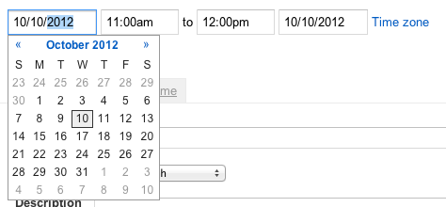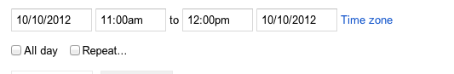
Now you are going to enter the details of your event. You will have the option to add guests on the right hand side. If you start to type their name you will get the dropdown of choices (similar to when you are writing an email).
You can select the Event color and add any Reminders you would like to have.
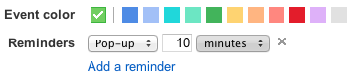
You will have the option of getting email or Pop-up reminders and when you would like those reminders.
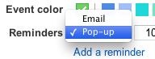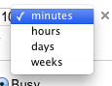
You will now need to choose if you want to be shown as Available or Busy and your Privacy setting.
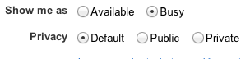
When you are done select the red Save button on the top left of your screen.
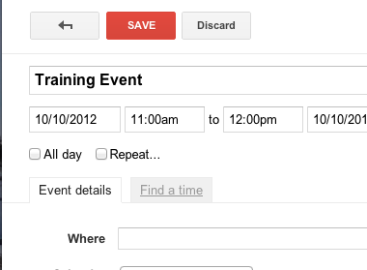

Your event will now show up on your Calendar.
