How to Create a New Google Contact Group

You will first want to log into your Google account. When you have logged in you then will be on your Google Drive homepage.

Go to the top of you screen and select Contacts. This will open up your contacts on a new tab.

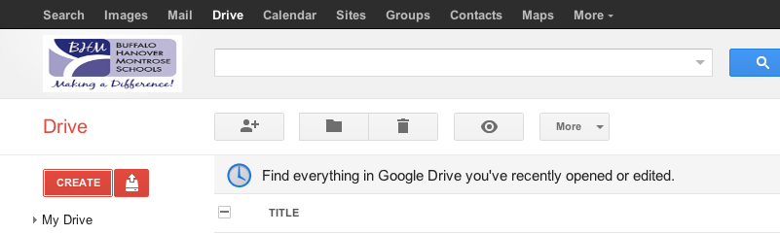

On the Left side select New Group.

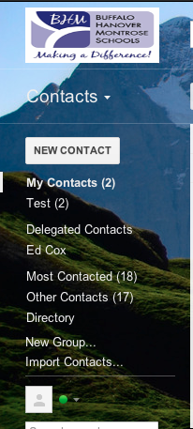

Now enter the name of your new group. Then select OK.

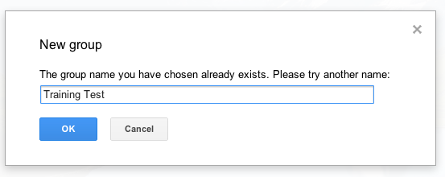
You will now want to add contacts into your group. Select the person icon.

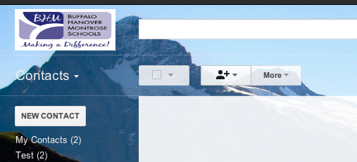
Start typing a name and their email address will pop up. You can add as many names as you would like. Then select the Add Button.

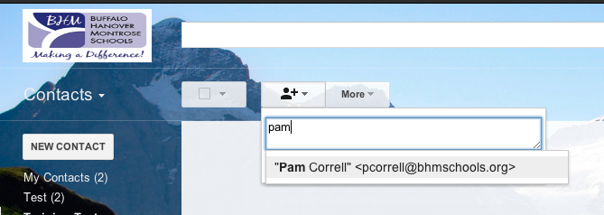

Once you have created your group and would like to share it with others select the More button at the top. Then on the drop down click on Export.

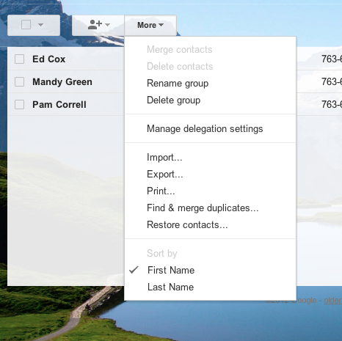
Then chose which contacts/groups you would like to share. Click on Export.
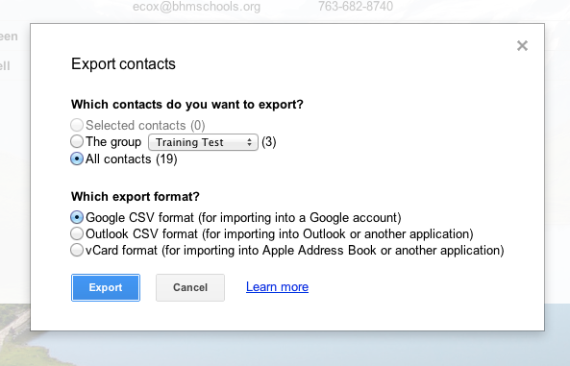
Your Contact Group will then be downloaded.

Go into your Mail.
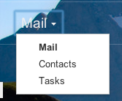

Select Compose.
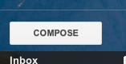
Write your email and put in the contact you would like to share your Contact Group with.
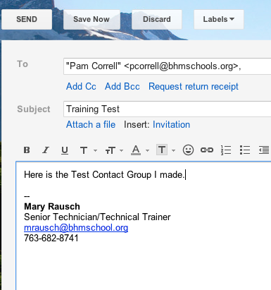

Attach the google.csv file that was downloaded.
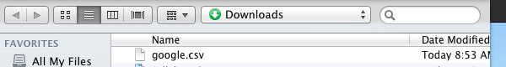

Send your email and you have now shared your Contact Group.
