How to Create a New Google Site

You will first want to log into your Google account. When you have logged in you then be on your Google Drive homepage.

Go to the top of you screen and select Sites. This will open up your calendar on a new tab.

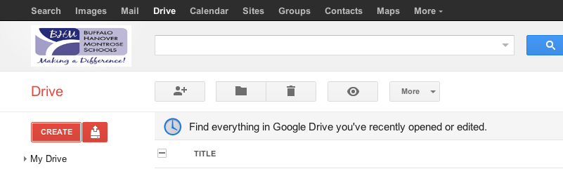

On the left side of the screen you will then want to select the red Create button.

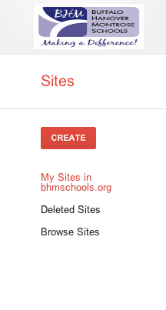

You will now be a new screen. This is where you will enter the name of your website. The Site Location will automatically fill in while you are typing the name of your website.
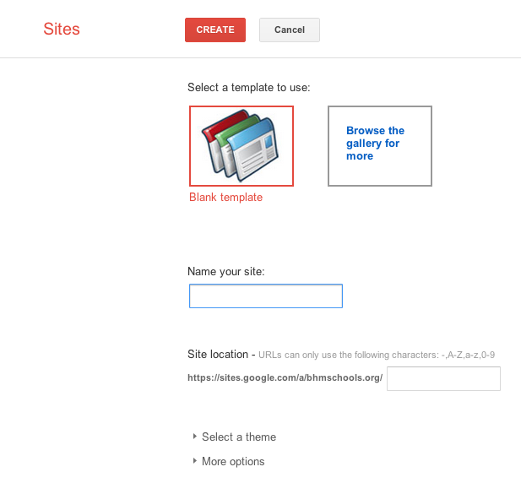

Click on the arrow next to Select a theme. It will then drop down and give you a selection of colored themes to chose from for your site.
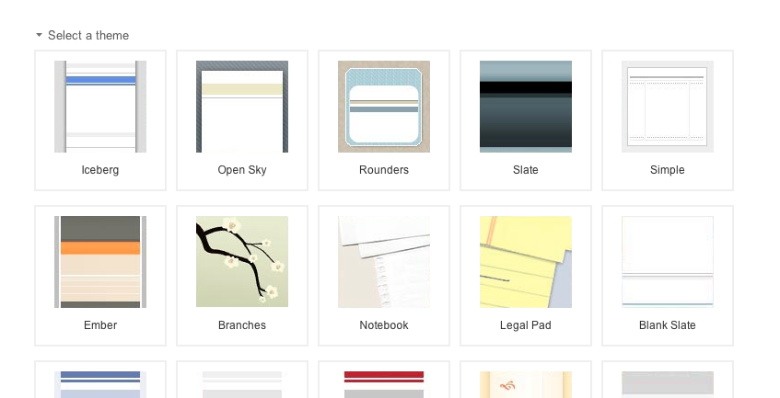

After you have selected your theme. Click on the arrow to the left of More Options. You will now be able to add a site category or site description.
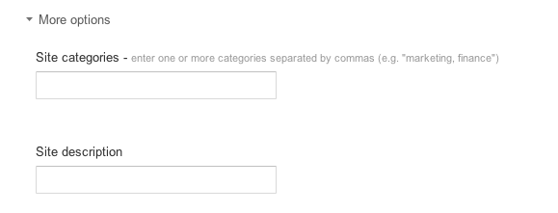

Once you are done you may then select the red Create button at the top of your screen.

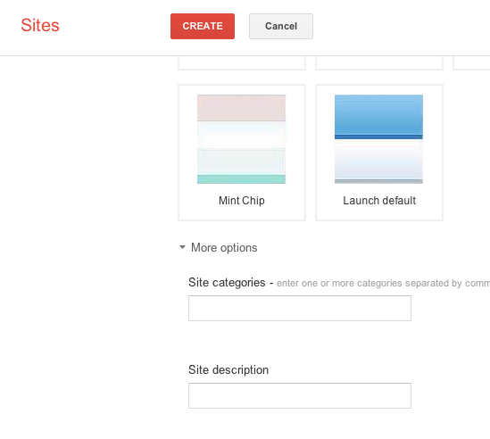
You will now be brought to your Google Site.

When you select the pencil icon on the upper right you will be able to edit your page. It will then make the page you are on turn into editing mode. This is where you can enter information and change your format.
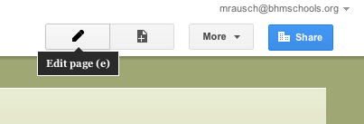
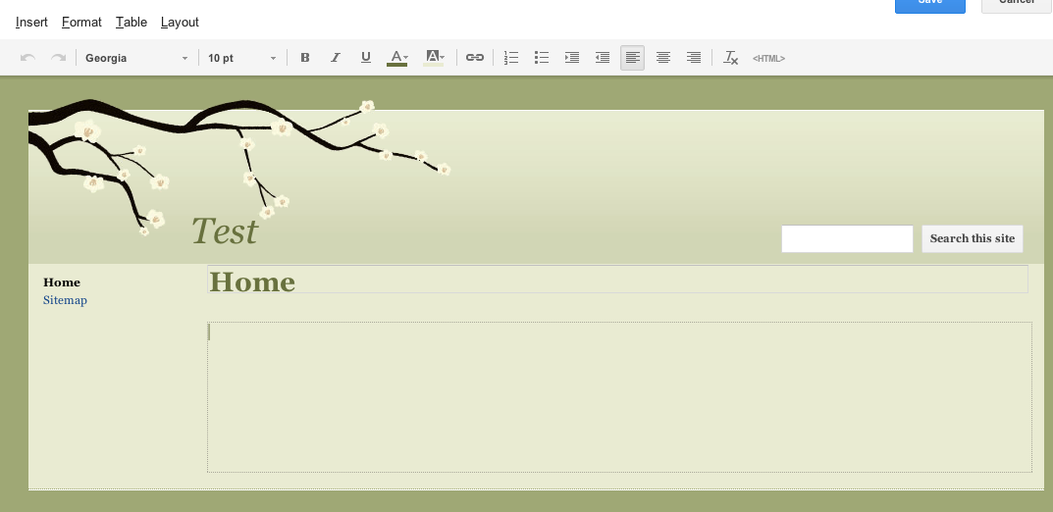

When you are done select the Save button on the upper right hand corner.

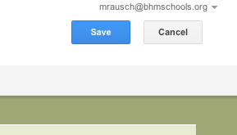
If you would like to add more pages select the New page button.
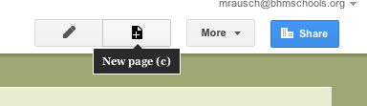
This will bring up a page for you to add the new page name. Put in the title of the page.

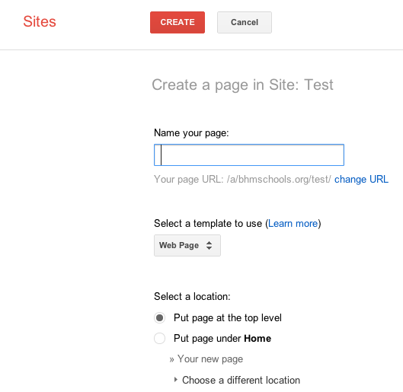
Select which template you would like to use.
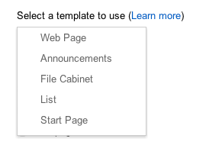

Web Page
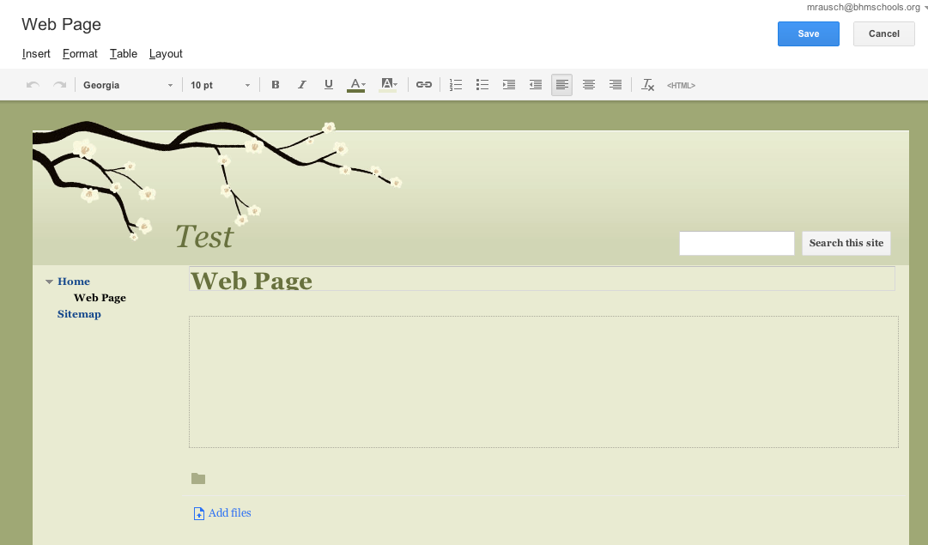

Announcements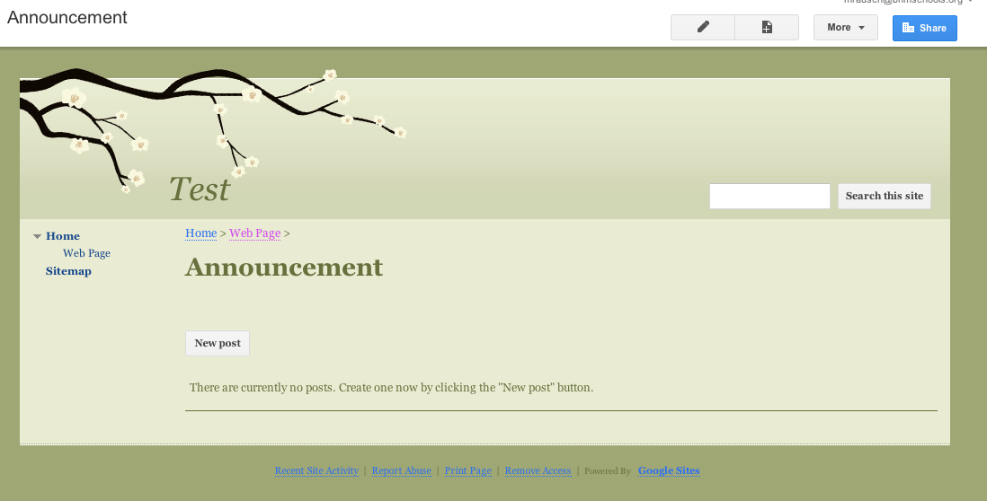

File Cabinet
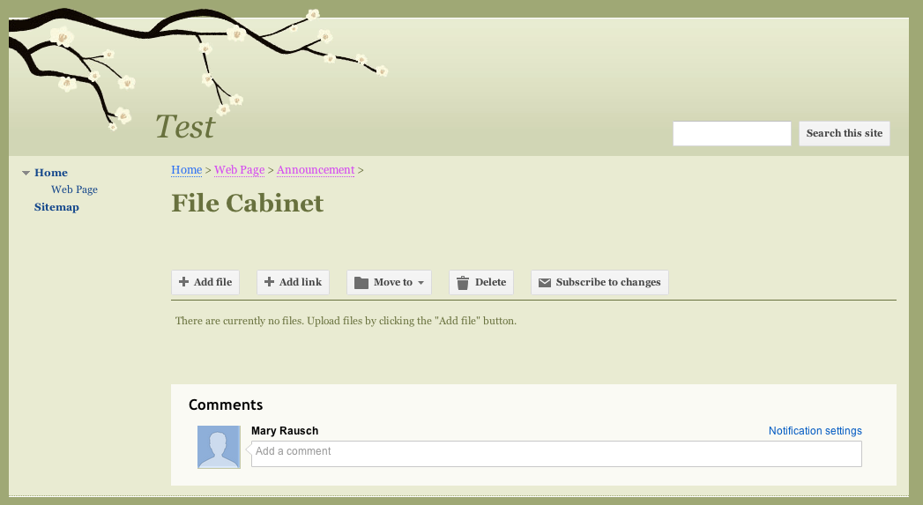

List
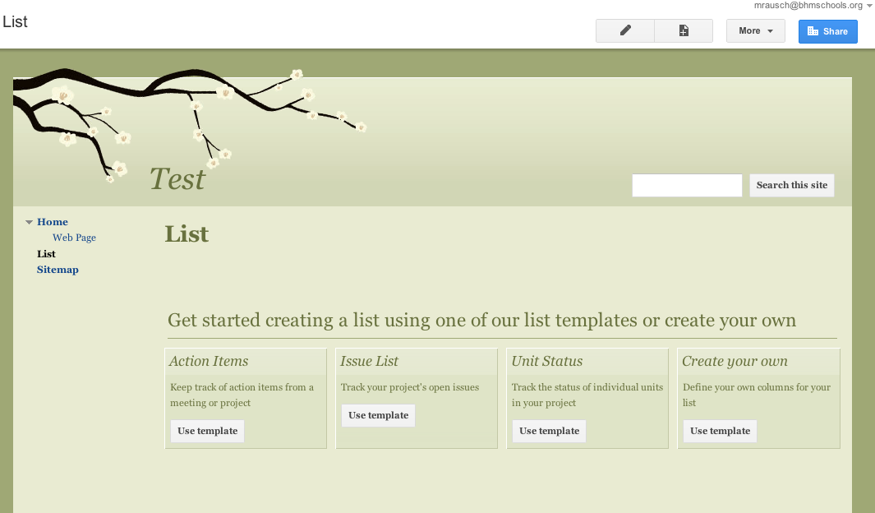
Start Page

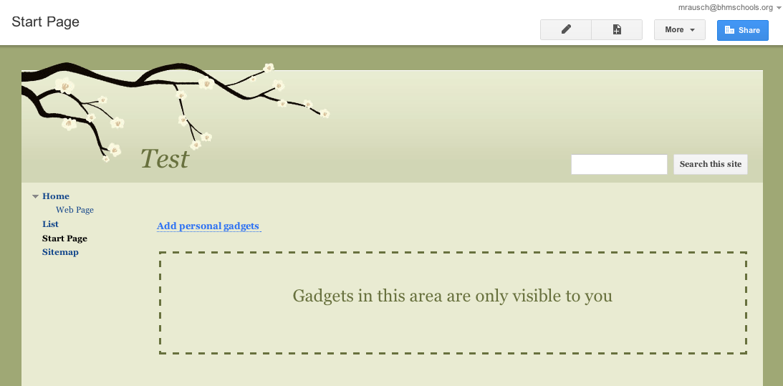

You will now need to select the location in which you would like your page to appear.
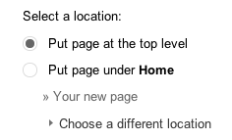
Once you are done select the red Create button at the top of your screen.

There are more options by selecting the More button in the upper right corner.
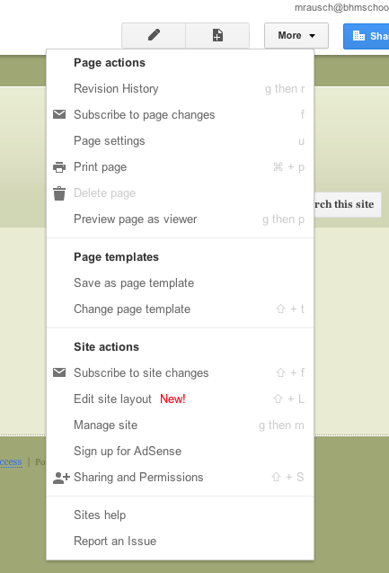
The three most important options are Edit Site Layout, Manage Site, and Sharing and Permissions

Edit Site Layout
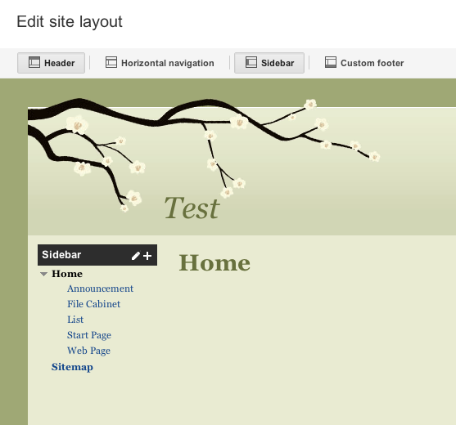
Manage Site
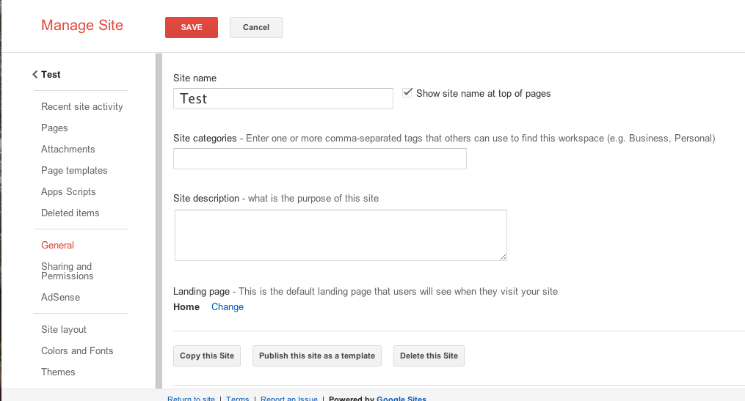
Sharing Permissions
