How To Create a YouTube Account

Go To YouTube.com
Click on Create Account

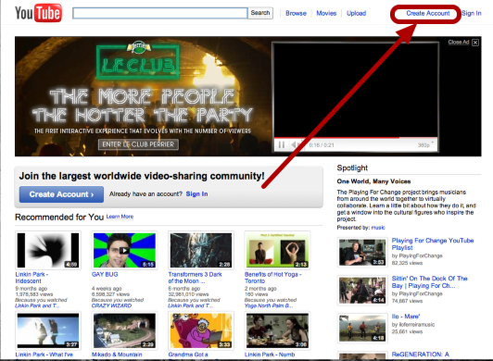

Enter Your Information
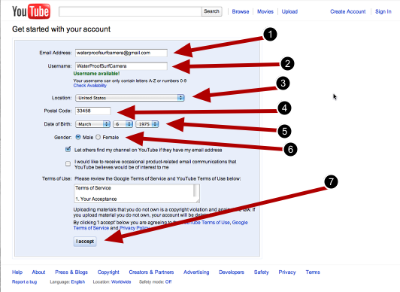
1.Enter your school Gmail email address.
2. Create Username
3. Choose your location
4. Enter your postal zip
5. Enter Your Date of Birth.
6. Select your gender
7. Click on “I Accept”.

Link Your YouTube Channel With Your Gmail Account
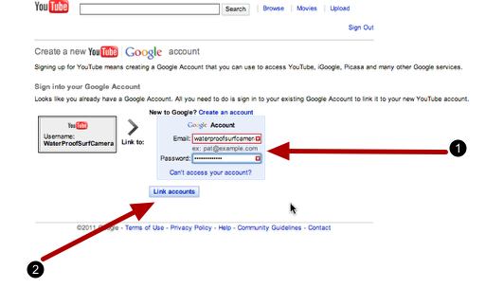
1. Enter your Email and password for your Gmail account (where the arrow is pointing) that you want to link your YouTube Channel.
2. Click on Link accounts

You have now successfully created your YouTube Account

