Uploading YouTube Videos

- Go to youtube.com and sign in using your school Google Docs login – username@bhmschools.org and your password.
- Across the top of the screen you will see Upload, click on it.

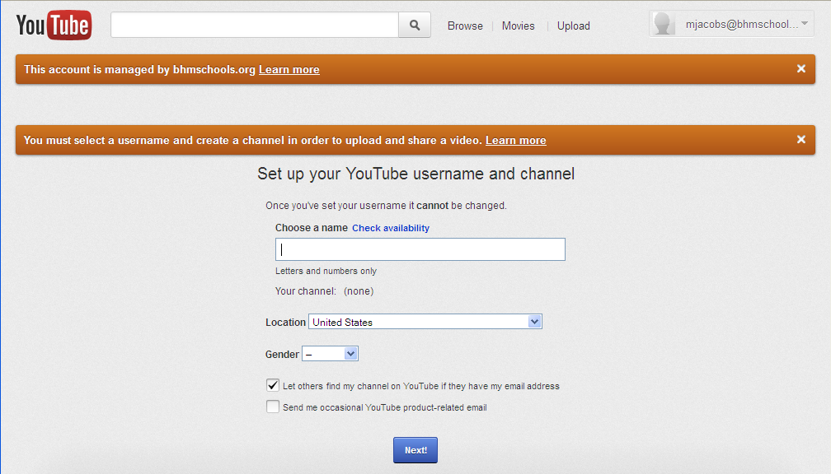
- If you haven’t already, you will need to set up a channel.
  - The name cannot have any spaces or unique characters. Suggestions would be either by the district or school acronym and your last name or subject area or username if it is unique enough. For example – BHMJacobs
  - Select your gender.
  - Read and check/uncheck the boxes to see if you want others to find you and if you want YouTube emails.
  - Click Next.
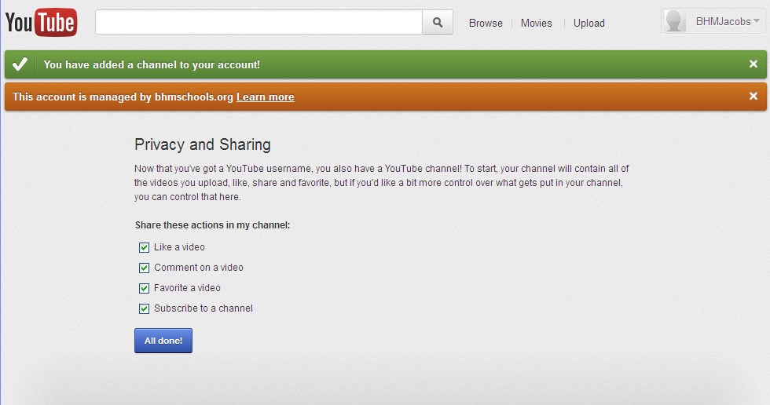
- Check your privacy and sharing settings. Click on All done!

To login after you create you channel, you still login with your gMail account information.
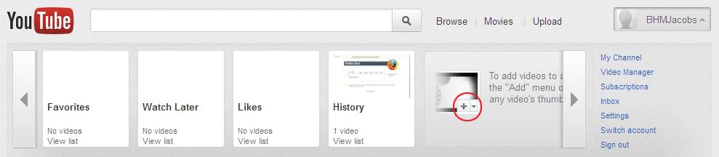
Click on your channel name (see circled) and it will open a menu bar.

Click on My Channel and it will open your landing page where you can either upload a video or click on Video Manager.

NOTE: See Sign out listed there too?!
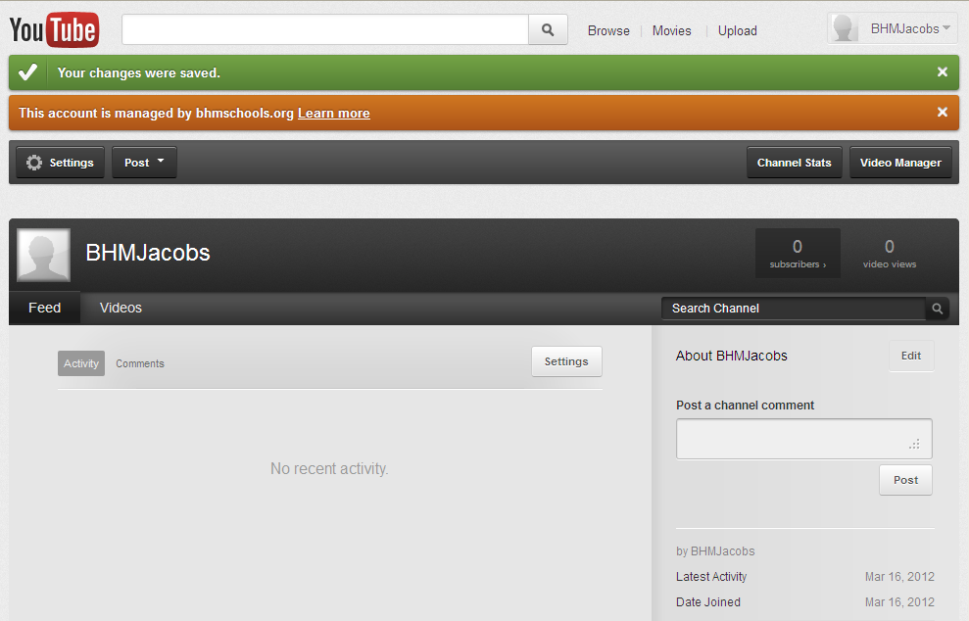
- Now let’s get back to uploading a video!

- Click on Upload in your new window.

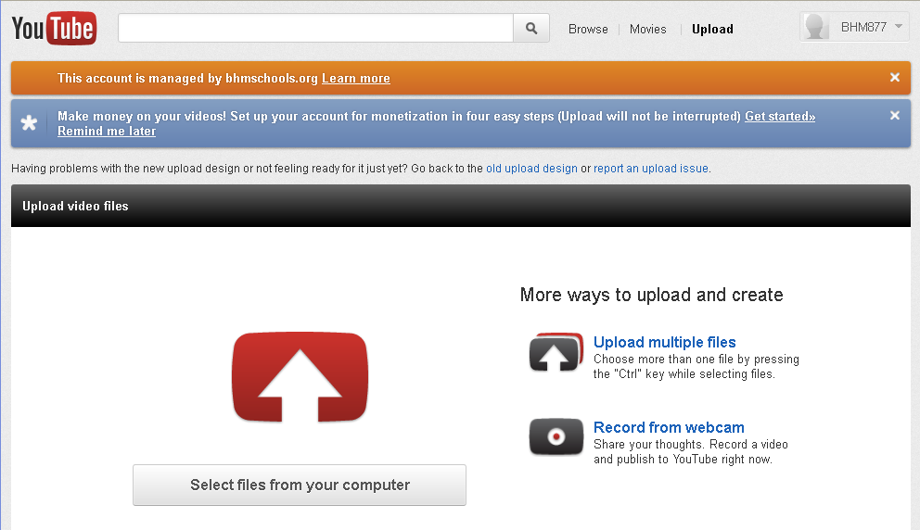
- Most likely you will click to Select files from your computer and browse to find the video.

- It will automatically start uploading the video

- There are settings to change….
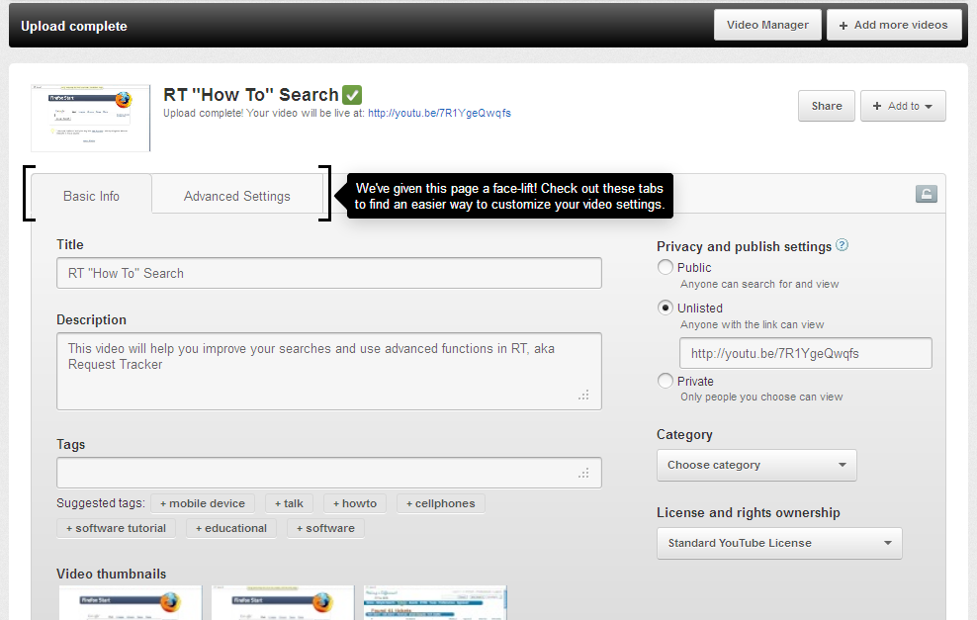
Basic Info tab
- Edit the Title as needed
- Enter a brief Description
- Under Privacy and publish settings, if you make the video Unlisted, a web address will populate (NOTE: that address will not work for students at school) but we’ll help with that shortly
- You can enter a category if you want, especially if you make it public
- For License, most videos will be created by staff/students so check Standard YouTube License
Advanced Settings tab
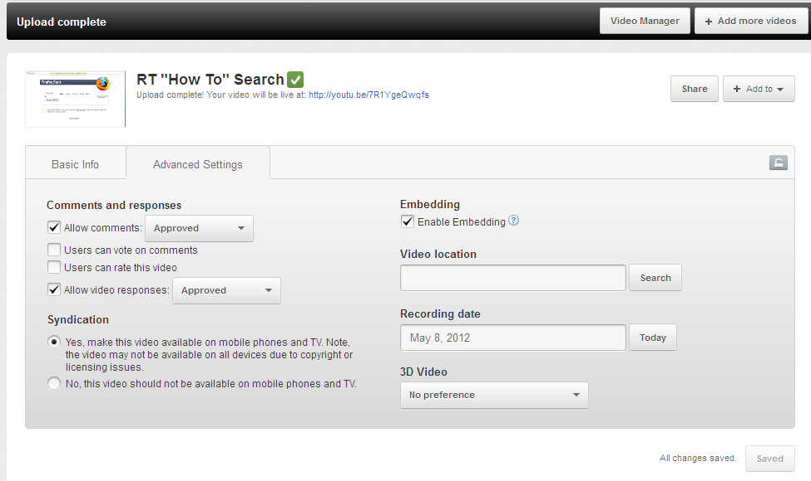
- Decide if you want Comments and responses to the video.
- Under Syndication, do you want the video available on mobile phones?
- Embedding lets the video be played inside another webpage, default is on.
- Video location can be selected if you are working with GPS coordinates or geography class.
- Recording date can be entered, if you click on the Today button, it will enter current date.
- 3D Video has options to make the video 3D…

- If you use the link (URL) provided under Unlisted on the Basic Info tab, currently most students would not be able to access it at school due to filtering. To get a regular YouTube URL…

- Click on the Share button (see in photo above, rectangle box)
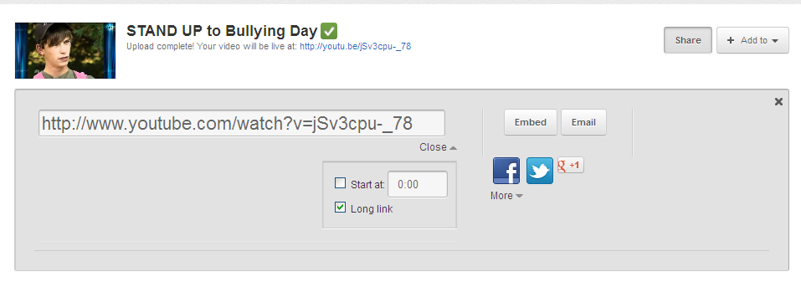
- Click on Options (switches to Close when activated).

- Click on Long link and get the true YouTube link (URL). That link should work within the school district.
Alternates between Options and Close

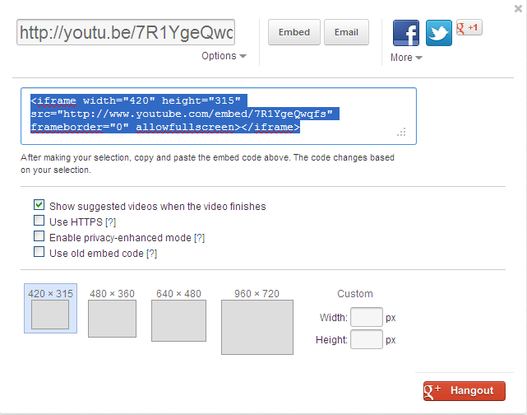
- So you want it to be viewed within your webpage? Click on the Embed button.

You can choose between different sizes of viewing frames when embedded on another webpage.

- Copy that code and pasted in the appropriate location/box on your webpage.

